**AIRPORT TRAVEL MANAGEMENT SYSTEM**



**MUNYARADZI G CHAMUKORERA**

**[T1852353Z 5118 TTT1 GROUP A&B 2018 TELECOMS]**

**Airport Travel Management System**

By

**MUNYARADZI G CHAMUKORERA**

 Submitted in partial fulfilment of the requirement for the National Diploma in Telecommunication’s

Submission; July 2021

Supervisor: MR SUWALI & MR HWEMA

**DECLARATIONS**

I hereby declare that I am the sole author of this dissertation. I authorize Trust Academy and the Midlands State University to lend this thesis to other institutions or individuals for the purpose of scholarly research

SUPERVISOR’s name: MR F SUWALI

SUPERVISOR’ signature: ______________________________________

DATE: ________________________________

**ABSTRACT**

Airport Travel Management System is a complete transport online application fully integrated travel system .This project is developed to manage the travelers for Airport Travel Company which is currently using manual system. . The use of an alternative new system is becoming a mandate to manage customers, notifying clients about their flight schedule and flight payments. This system initially uses a web based database coupled with RFID tagging system with acquire finish framework purpose the place the majority of the data may be manipulated

**ACKNOWLEDGEMENT**

Firstly, l am grateful for the work made possible due to God’s will. Special thanks to my supervisor MR Suwali, projects coordinator MR Chigwere, my core supervisor Mr Hwema for their guidance and support. Furthermore, this project would not have been successful without support and guidance from all Lecturers at large, in the Telecoms Department at Telone Centre For Learning. To me they have been springs of knowledge. I also appreciate the assistance given by our colleagues and school mates in any degree. Without forgetting assistance and moral support from our parents, we are humbled to have such. Thank you all.

**DEDICATION**

I dedicate this project to our families, my project supervisor Mr. Suwali and Mr Hwema who made this project a success

**TABLE OF CONTENTS**

**LIST OF APPENDICES**

* Questionnaires
* User Manuals
* Observation Sheet

**1.1 INTRODUCTION**

Travel management system is a web-based application designed for Airport Travel. As an innovator the current manual system being used to record data and information is not easy, has so many disadvantages and l fully supported Airport Travel Company.

**1.2 BACKGROUND INFORMATION**

Airport Travel is a company located in Harare Zimbabwe, it specializes in transporting people in between Zimbabwe cities and across borders. This company consist of mainly hundred placed in various branches of Airport Travel Company across the country. It offers 24/7 of service to customers during normal days. All of the Airport Travel operations and day to day services are recorded manually and are stored in hard files for example all the flight bookings and hotel bookings are done manually. All the transactions which pertains to monthly income activities are done by a hired professional accountant at the end of each month.

**1.3 PROBLEM DEFINITION**

The Airport Travel Company is a recently established company which uses manual system to record its data and information. The Accountant at the end of each month manually calculate the financial balance of the Airport Travel this opens a huge room for errors in the business management. It is difficult to manipulate data stored in hard files for example employee records. There is duplication of data since the same data is recorded and stored in different files each day. Management of Airport Travel records by the use of manual system is tedious and opens a huge room to error results. The records occupies a lot of space which might be used for other work which might be beneficial to the company. Delayed processing of query and payments.

**1.4 OBECTIVES**

To notify clients about their flight schedule through email

To allow online flight payments

To calculate flight charges

To allow online flight booking

**1.5 FUNCTIONALITY**

Expand the market

Manage and monitor Airport Travel operations

**1.7 JUSTIFICATION**

**Advantages**

The system allows the new user to create account before entering the system only with admin’s permission, username and password.

The system is able to capture errors during data input and also correct the errors, pop a message

**Limitations**

When an error occurs the system is just able to detect that an error has occurred by showing the message on the message box and the system is not able to tell the user on how to correct the error.

**1.8 CONCLUSION**

The need for an online system leads to the planning phase relating to the proposed system.

**CHAPTER 2 PLANNING PHASE**

**2.0 PLANNING**

The act of formulating of a course of action or drawing of plans relating to Travel Management system. This involves time frame and resources needed during the planning phase of the proposed system .Involves software and hardware part .Software Requirements:

Operating system: Windows {7, 8, 10}, Microsoft packages (Excel, Access)

Visual basic

HARDWARE REQUIREMENTS

|  |  |  |  |
| --- | --- | --- | --- |
| *INPUT* | *Storage* | *Output* | *Processor:* |
| **Scanner** | . {RAM} 2G and above are required. | . Printer | Intel {R} Celeron {R} |
| **Barcode** | . Hard disk capacity: 300G and above are required. | Monitor |  |
| **Printer** |  |  |  |

**2.1 WHY BUILT THE SYSTEM**

Security and integrity to data records will be enhanced. They will be an increase in the profit making of the company. Easy access to system records. Security to records is enhanced. Easy to calculate sales. Reports on the progress of the company’s performance can easily be acquired by looking at the graphs on sales provided by the off the shelf package

**2.2 BUSINESS VALUE**

This is the entire value of the business and encompasses all elements that determine the well-being and healthy of this project which includes brand recognition and trademarks also financial assets and equity of this Travel Management system which leads to day to day supervision of the company and calculating profit generated

**2.3 INFORMATION GATHERING METHODS**

Information gathering is necessary so as to have enough understanding of the current system which leads to requirements determination. And to gather useful information, the following fact-finding techniques were employed:

### 2.3.1 Participatory

– this proved to be the most effective technique. It generally involved my personally involvement in the operational activities of the procurement system at Telone Center for learning. I observed the registration of suppliers of resources, scheduling of biddings and tender notification process and also how reports where developed. Getting personally involved helped me to identify some bottlenecks that could have otherwise gone unnoticed. It also helped me to get that much needed first-hand experience of the problems being faced by the users of the current system.

### 2.3.2 Observation and Document Review

– this involved observing those operations that I could personally get involved in during the participatory activities. This helped in verifying details gained at participatory activities. I observed all steps in the registration system and, examined and reviewed forms, records and reports used throughout the organization.

## Advantages of observation

1. observation allow the analysts to assess the general moral of workers
2. tasks that are difficult to describe are easily observed
3. first-hand information is obtained

## Disadvantages of observation

1. employees may feel uncomfortable being watched and can put up an act intended to influence the judgment of the observer
2. the method is demanding in terms of personal commitment
3. it is time consuming as analysts may take several days to come up with the correct information about the system being investigated

### 2.3.3 Interviews

I also conducted interviews with identified key employees within the board. The interviews helped to give an insight of how theleague functions, and to provide answers to questions that could not be answered by the former techniques. For staff at the same level, asked the same interview script to help me get a wide range of answers and opinions on similar topics or issues.

Advantages interviews

1. the researcher can get more detailed and first-hand information about a topic or event
2. the interviewer can observe the reactions of the interviewees and is able to probe for clarification for answers
3. interview is flexible since the interviewer can modify questions that interviewees have not understand so that they understand them and therefore response is immediate

## Disadvantages of interviews

1. they are time consuming
2. they require certain skill to get maximum information, that is the interviewer must be a good communicator
3. interview is difficult to organize because of employees’ busy schedule
4. for retrieval of maximum information, interviewees must be assured of discussing in privacy

### 2.3.4 Questionnaire

Questionnaires were presented to staff at the board. The purpose was to gain some preview into the already existing system through the users’ opinion. A date was set for the return of the questionnaire

## Advantages of questionnaires

1. Respondents completed questions at their convenience, as there was ample time for them to think about the questions before responding and thus allowing them to give comprehensive answers.
2. It was easier to arrange and conduct as compared to interviews as there is no personal monitoring.
3. It saves time as it was distributed to many respondents’ con-currently
4. Anonymity was maintained which enhanced the chances of genuine responses, as there was no room for intimidation by other employees.

## Disadvantages of questionnaires

1. The return rate did not match the number of questionnaires handed out.
2. Questionnaires were time consuming as the response was not immediate as in the case with interviews
3. There are no guarantees that respondents would answer all questions posed as some questions came back unanswered or poorly answered.

The fact-finding techniques helped me to achieve a high-level understanding of the current system, which is described below

**TANGABLE BENEFITS**

Less stationery cost, use of hard copies used to register suppliers will be eliminated by online registration

Reduced staff cost: the cost paying extra staff is cut by the new system thus allowing funds to be diverted to other activities.

Reduction in staff working time: due to computer’s supreme and massive calculating information processing speed power the system is going to guarantee the staff a reduction in work.

**INTANGABLE BENEFITS**

Easy access to system records.

Security to records is enhanced

## **2.6 FEASIBILITY STUDY**

“Are the necessary components in place for the initiation of the project?”

Before embarking on project, it is essential to verify whether it is feasible to carry out that project. The feasibility can be characterized into technical, economic and operational. This feasibility analysis enables the analyst to provide justification on whether the proposed desired objectives can be achieved within the prevailing economic, financial, organizational and technological constraints and a descriptive comparison between the benefits and the costs.

**2.6.1 Technical feasibility:**

The proposed system will be characterized by new technology and thus it is essential to validate its technical feasibility. The extent of the successful development and implementation of the system also depend on the availability of technical expertise. An analysis of the current infrastructure at shows that it is sufficient enough for the system to be said to be technically feasible to develop and implement.

The following are some of the reasons that verify the technical feasibility of the system:

- There is a fully fledged network system at Airport Travel that has at least a servers operating well below their actual capacity.

* The developer who is going to be responsible for the creation and deployment of the system has the necessary technical expertise to carry out the project.
* Most of the users are computer literate and have practical experience working with computers and should not have minimum problems with running the system.

**2.6.2 Economic feasibility:**

Can the expected benefits outweigh the costs to be incurred by the system?

Does the team have sufficient resources to finance the proposed system?

The internet allows for the download of open source developer tools such as the ones which are being used to create the system. This means little or no money is required for the purchase of software. In as far as hardware is concerned, it has been mentioned already that Airport Travel has the necessary infrastructure in place but it is just that it is not fully utilizing the resources. A survey was also conducted to examine the extent to which the benefits outweigh the costs and the developer was able to come up with the following cost benefit analysis:

**2.6.3 Operational feasibility:**

This defines acceptability of the system by users as a solution to their current problems. This also defines the friendliness of the system to users, thus ease of use. In exploring operational feasibility, the PIECES (performance, information, economy, control, efficiency, services) framework is used.

**Performance**- the new system will provide adequate response time

**Information-**the new system will provide accurate, useful and timely information to users and management.

**Economy** -the current manual system provides cost ineffective information to the business because there are high time costs incurred in retrieving information. The new system will provide timely information and help reduce telecommunication costs.

**Control-** the current manual system is prone to fraud and has no guaranteed security. The new system offers effective control to protect` against fraud and unauthorized access. It reduces the number of errors made during data entry.

**Efficiency-** the new system will take lesser time to process information and to produce more accurate results, thereby making it more efficient than the current one.

**Services-** the new system will provide more reliable services, which are flexible.

**2.6.7 RISKY ANALYSIS:**

It helps us access threats to the company, provided input into how to manage this risks and to enable us to communicate more effectively with the clients about how best to deal with risks

**WORK PLAN**

**GANT CHART**

Task description

|  |  |  |  |  |  |  |
| --- | --- | --- | --- | --- | --- | --- |
| Project proposal |  |  | | | | |
| Feasibility report |  |  |  | | | |
| System analysis |  | |  |  | | |
| System design |  | | |  |  | |
| Implementation |  | | | |  |  |
| Evaluation and  Maintenance |  | | | | |  |
| Documentation |  | | | | | |

**Conclusion**

In conclusion planning phase made possible due to availability of resources and the ability to take correct procedures

**CHAPTER 3 ANALYSIS PHASE**

**INTRODUCTION**

After analyzing the requirements of the work to be performed, the next step is to consider the problem and understand its content. Studying the existing system is the first step and the other is understanding the requirements and domain of the system

**ANALYSIS OF EXISTING SYSTEM**

The current Airport Travel system is manually based which means almost every work in the company performed on paperwork. Data and records are not safely secured they can be accessed by anyone.

The current manual system is not efficient when we look at the management in movement of busses and their drivers and also their locations.

Computerization is only used for giving bills and receipts for the booked seats.

Absence of any alarm which gives an awareness if the number of seats booked in the bus has been exceeded

It is difficult in retrieving data. So generally the current system does not store data in a systematic way system requires the employees to consistently monitor and count manually the receipts sold

**DATA ANALYSIS**

ADMIN IS REGISISTED

ADMIN LOGIN ID & PASSWORD

CHECK LOGIN ID

PASSWORD

INVALID

**No**

**Yes**

LOGIN SUCCESSSFUL

SET USER LEVEL PERMISSION

**OVERVIEW OF THE PROPOSED SYSTEM**

It shows the flows between the activity of login, payments, customer information and booking process. The user will be able to search and generate report. It shows the activity flow of editing, adding and updating payments. Features of an Airport Travel management are; travel request, easy travel booking, budget friendly, advanced reporting and approval hierarchies

**Strengths of the current system**:

A trained profession is not required to use the current system.

Passenger’s records are not prone to hacking because they are stored in the form of paperwork.

**Evaluation of Alternatives**:

No security to information pertaining to passengers, Airport Travel daily transactions records because they are no security measures which are undertaken to keep them securely.

A lot of money is consistently required to cover for the expenses in buying books to collect employee’s records, customer records, recording sales and other things required to store the data

The company is incurring expenses in renting a room for the collecting and storing information of the company

The company is hiring a trained accountant to calculate the monthly sales this is an expense to the cafe.

They is no reliable backup of data because hardcopy records can easily be burnt and lost.

The profits are being reduced by some petty expenses

**EVALUATION OF ALTERNATIVES**

i) Buying an off the shelve package

ii) Upgrade the current system

**i) Buying a software package**

**Advantages of buying off the shelve package:**

Easy access to system records.

Security to records is enhanced.

Easy to calculate sales.

Reports on the progress of the company’s performance can easily be acquired by looking at the graphs on sales provided by the off the shelf package

**Disadvantages**:

Off the shelve might not meet the exact requirements of the café.

Off the shelve packages might be expensive

It time consuming to look for software package that might meet the requirements of one’s cafe king at the graphs on sales provided by the off the shelf package.

**Upgrading the current system**

This part allows for the existing system users to look closely on the current system and find those areas which need adjustments to improve the current system performance.

Employ a salesman with a bachelor’s degree in accounting this reduce expenses on the company in hiring an accountant at the end of every month. Going through the transactions at the end of the day to look if they is any errors in the records.

Use of biometric security to restrict the number of system users who have access to the companies’ records.

Use of Microsoft Excel to calculate sales at the end of each day so that they would be a clear pattern on which stock which are being frequently bought.

**Advantages:**

Security and integrity to data records is enhanced.

They will be an increase in the profit making of the company

**Disadvantages:**

Employing an account is expensive.

It time consuming to look record by record of every passenger.

Expenses are incurred when hiring a system analyst when a system is being upgraded use of biometric in security system is expensive than to hire a system analyst and create a new system for the company

However, the new system enables maintaining data security, integrity by use of validation, verification and passwords also the online booking system which it offers to the clients. Tailor made software meets basically all the requirements of the company. The programmer has the knowledge of the user requirements. Tailor made software consist of all what the user and programmer insist on the user requirements and they are no unwanted features. The system interface can be created in such a way that it easy for the users to use (User friendly)

**REQUIREMENT ANALYSIS**

It’s an online based application .The main purpose is to provide convenient and easy way for customers to book flights

**S**

UNREGISTERED USER (SIGN UP)

REGISTERED USER (SIGN UP)

SYSTEM USER

STAFF

**CONCLUSION**

After meeting all the demands of the planning phase method it involve introduction of a computerized tailor made system to handle the day to day running of the company records leads to design phase **.**

**CHAPTER 4**

**DESIGN PHASE**

**INTRODUCTION**

This is the phase that bridges the gap between problem domain and the existing system in a manageable way .The complex activity of a system development is divided into several smaller sub activities which coordinate with each other to achieve the main objective o system development.

**SYSTEM DESIGN**

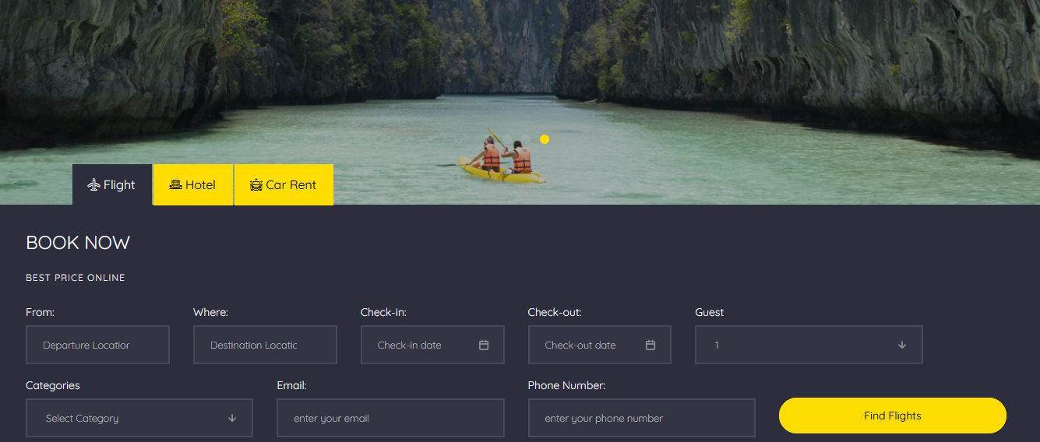

**SYSTEM INPUTS**

Must have features of a travel management system

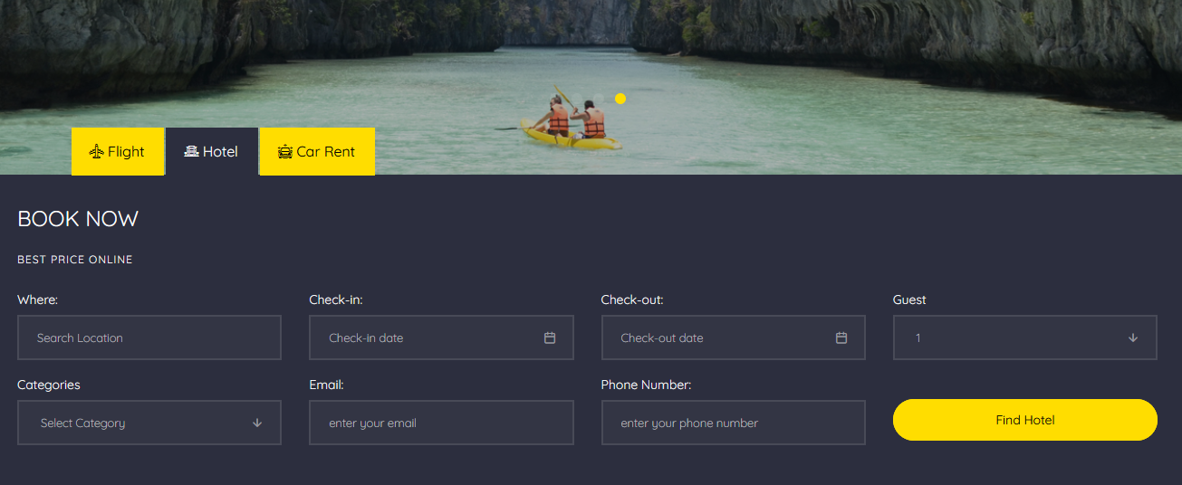

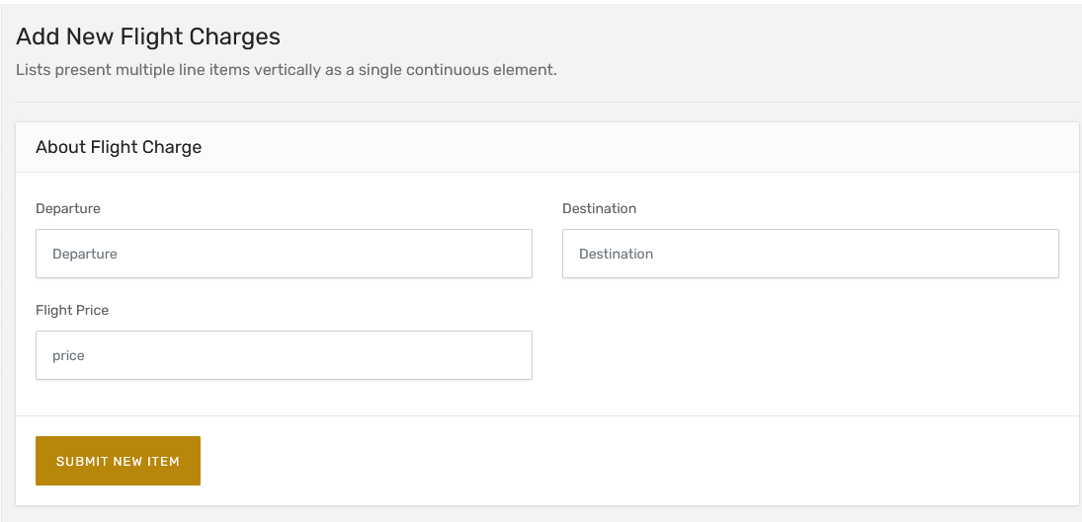

**SYSTEM PROCESSES**



Start



Enter:

Username

:

:

Password



Is

:

:

Username

Password

:

CORRECT



Main Form

NO

YES



Start

Create Account button

**SYSTEM OUTPUT**

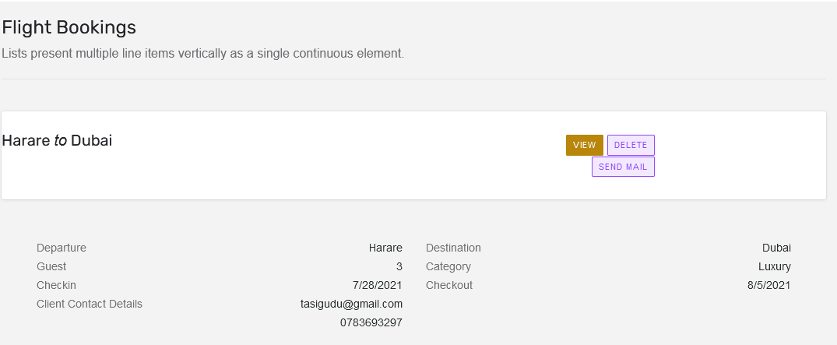

**ARCHITECTURE DESIGN**

WEB SERVER

VISUAL BASIC

FRONTED

What user sees and interact with (VB, HTML)

USER

FILE SYSTEM

(HTML ,CSS)

DATABASE

**PHYSICAL DESIGN**

PACKAGE MANAGEMENT

BOOKING MANAGEMENT

TRANSPORT MANAGEMENT

CUSTOMER MANAGEMENT



Start



Enter:

Username

:

:

Password



Is

:

:

Username

Password

:

CORRECT



Main Form

NO

YES



Start

**INTERFACE DESIGN**

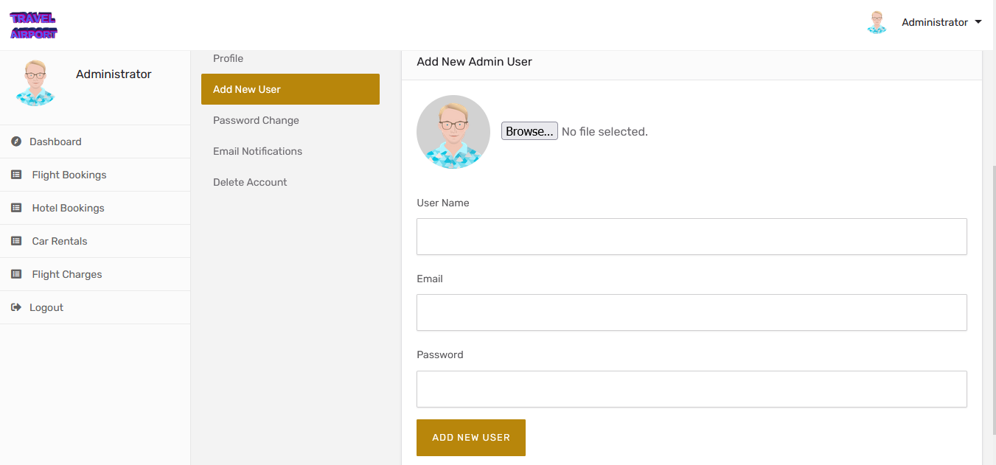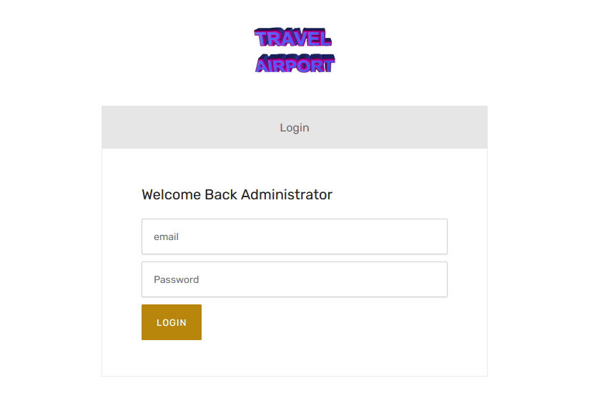

**DATABASE DESIGN**

**Er diagram**

ADMIN

USER

MANAGES

MAP ROUTE

STORESS

SELECTS

BOOKING

DISPLAY

LOCATION

**CLASS DIAGRAM**

ROLE CLASS USER CLASS

+booking_type: string

+booking_description: string

+booking_date: date

+addBooking ()

+user_id: int

+user_name: string

+user_address: string

+role_id: int

+role_tittle: string

+role_description: string

CUSTOMER CLASS BOOKING CLASS

+customer_id: int

+customer_name: string

+customer_mobile: string

+customer_email: string

**CONCLUSION**

CHAPTER 5: IMPLEMENTATION AND TESTING

5.0 IMPLEMENTATION: INTRODUCTION

In the previous section, the various designs were laid out and a workable one was decided on which shall now be implemented. There has also been given an outline of how the input and output of the proposed system will be like. In this chapter, the developer exhibits sample codes that will help in getting what expected output from the system and the various ways in which the new system can be tested and these are discussed in this section.

5.1 Coding and Construction

This section we will discuss the programming language that will be used for developing, programming style, data storage, connection method, processing method as well as the input and output methods.

<?php

include "db.php";

?>

<!DOCTYPE HTML>

<html>

<head>

<meta charset="utf-8">

<meta http-equiv="X-UA-Compatible" content="IE=edge">

<title>Travel Management System</title>

<meta name="viewport" content="width=device-width, initial-scale=1">

<meta name="description" content="" />

<meta name="keywords" content="" />

<meta name="author" content="" />

<!-- Facebook and Twitter integration -->

<meta property="og:title" content=""/>

<meta property="og:image" content=""/>

<meta property="og:url" content=""/>

<meta property="og:site_name" content=""/>

<meta property="og:description" content=""/>

<meta name="twitter:title" content="" />

<meta name="twitter:image" content="" />

<meta name="twitter:url" content="" />

<meta name="twitter:card" content="" />

<link href="https://fonts.googleapis.com/css?family=Quicksand:300,400,500,700" rel="stylesheet">

<!-- Animate.css -->

<link rel="stylesheet" href="css/animate.css">

<!-- Icomoon Icon Fonts-->

<link rel="stylesheet" href="css/icomoon.css">

<!-- Bootstrap -->

<link rel="stylesheet" href="css/bootstrap.css">

<!-- Magnific Popup -->

<link rel="stylesheet" href="css/magnific-popup.css">

<!-- Flexslider -->

<link rel="stylesheet" href="css/flexslider.css">

<!-- Owl Carousel -->

<link rel="stylesheet" href="css/owl.carousel.min.css">

<link rel="stylesheet" href="css/owl.theme.default.min.css">

<!-- Date Picker -->

<link rel="stylesheet" href="css/bootstrap-datepicker.css">

<!-- Flaticons -->

<link rel="stylesheet" href="fonts/flaticon/font/flaticon.css">

<!-- Theme style -->

<link rel="stylesheet" href="css/style.css">

<!-- Modernizr JS -->

<script src="js/modernizr-2.6.2.min.js"></script>

<!-- FOR IE9 below -->

<!--[if lt IE 9]>

<script src="js/respond.min.js"></script>

<![endif]-->

</head>

<body>

<div class="colorlib-loader"></div>

<div id="page">

<nav class="colorlib-nav" role="navigation">

<div class="top-menu">

<div class="container-fluid">

<div class="row">

<div class="col-xs-2">

<div id="colorlib-logo"><a href="index.php"><img src="images/logo.png" style="height: 80px"></a></div>

</div>

<div class="col-xs-10 text-right menu-1">

<ul>

<li class="active"><a href="index.php">Home</a></li>

<!-- <li class="has-dropdown">-->

<!-- <a href="tours.php">Tours</a>-->

<!-- <ul class="dropdown">-->

<!-- <li><a href="#">Destination</a></li>-->

<!-- <li><a href="#">Cruises</a></li>-->

<!-- <li><a href="#">Hotels</a></li>-->

<!-- <li><a href="#">Booking</a></li>-->

<!-- </ul>-->

<!-- </li>-->

<li><a href="charges.php">Flight Charges</a></li>

<!-- <li><a href="hotels.php">Hotels</a></li>-->

<li><a href="services.php">Services</a></li>

<!-- <li><a href="blog.php">Blog</a></li>-->

<!-- <li><a href="about.php">About</a></li>-->

<li><a href="contact.php">Contact</a></li>

</ul>

</div>

</div>

</div>

</div>

</nav>

### **5.2 TESTING**

Before the system can be installed on a client’s machine it is essential to conduct tests so as to check for errors such as syntax errors and some errors which might compromise on the quality of the system.

The testing was carried out in the following phases:

* Unit testing
* Module testing
* System testing
* Acceptance testing

### **5.2.1 Unit testing**

The testing technique focuses on a unit of the program which can either be a function or a module.

Two different techniques that we used for the unit testing and these are:

**Black box testing**- this involved testing of the inputs and outputs produced by the system without taking into consideration the internal operations of the system. This involves checking outputs such as reports to verify whether they were producing the required outputs.

**White box testing**- this pays detail to the internal processes of the system. It focuses on the internal working detail of a unit and identifies errors not shown through black box.

### **5.2.2 Module testing**

This is also called link testing. It tests a collection of intergraded modules into a subsystem. It ensures job streams are correct. There is detection of interface mismatches and rigorous exercise of the interface between programs. The modules, which are linked together, were tested.

### **5.2.3 Interface testing**

In this section the following conclusions were drawn about the interface:

* All data content contained within the window is properly addressable with a mouse function keys and keyboard shortcuts.
* All functions that relate to the windows are available when needed.
* All the windows close properly.
* All tools on interface serve a function.
* All relevant pull-down menus, tool bars, dialog boxes, buttons, icon, and other controls are available and properly displayed for the windows.
* All the information needed from the user is accessible from the interface tools, i.e., can the interface effectively accepts.

### **5.2.4 System testing**

This testing technique involves cycle tests all programs and ensure that everything necessary is in place for instance proper documentation. It involves testing of the whole system to measure efficiency and effectiveness of the system. It is essential to measure the systems functionality with stated objectives and this is done during the process of system testing. Functions such as security and output generation will be taken into account as users go through the system. There are also other issues that are taken into consideration such as compatibility of the software to the hardware and how the system will adapt to computer threats.

### **5.3 SECURITY**

#### 5.3.1 Physical Security

The servers and all client machines will be stored in locked rooms. The security features of this kind are already in place. The use of security guard will be implemented to ensure that the system will not be vandalized.

#### 5.3.2 Software Security

Authorization to access the system will be granted according to user levels and a user will also be required to supply a password before he/she can gain access to the system.

## **5.4 INSTALLATION**

To install the system, for the tests and training

Get the file from the device using a flash and Click My Computer on the desktop and right click the mouse. Click Explore to view all the drives on your computer.

Select Compact Disc (D:) or flash drive and right click the mouse as above. This time you can choose either Open or Explore. Select project and copy it.

Use either wamp or xampp of these servers to start the control panel so that your server will start running.

Set the systems home page to be the default page when you start internet explorer. Double click internet explorer on the desktop to access the system.

You can then safely run the program

**5.4.1 To install and host the system for final use.**

The final installation stage involves the uploading and hosting of the Airport Travel web-based system on to the web server to enable online access to everyone.

1. Click the "File" menu followed by the "Site Manager" item on the menu. A dialog box will appear.

2. Click the "New Site" button on that dialog box. This creates a new item under

"My FTP Sites" called "New FTP site". Rename "New FTP site" to the name of your site if you wish. By default, the keyboard cursor would have been placed in the name portion of "New FTP site" allowing you to change the name immediately. If you have lost the cursor because you accidentally clicked somewhere else in the dialog box, you can get it back by simply clicking once on the name. Note that this name can be anything you wish - it is not required for accessing your site. However, you will probably make your life easier if you change the name to that of your site rather than the cryptic "New FTP site".

3. Under the tab "General”, enter the name of your FTP server in the "Host" input box. Enter the hostname into the space provided.

4. Leave the "Port" and the "Server type" entry boxes alone. Use your mouse and select "Normal" from the drop-down list box for "Logon type". This will enable the "User" and "Password" boxes for the next step.

5. Enter your user id or your login name (or whatever your web host calls it) into the "User" input box. Likewise, enter your password into the "Password" input box. Note that this information is automatically saved onto your computer and will be re-used the next time you run FileZilla, so you do not have to re-enter them again. (It also means that you should not use FileZilla in this way on computers that others may have access to, such as those found in an Internet cafe or a public library.)

6. Click the "Connect" button. FileZilla will proceed to log you into your server. If it is successful, you will see a directory listing of your website's account in the right-hand side of the FileZilla window. The left-hand side of the FileZilla window shows the directories and files on your own computer.

7. Only upload a specific subdirectory on the web server, such as in the "www" or "public_html" directory, change to that directory by double clicking its name in the folder portion of the right window pane (the "Remote Site" window pane).

FileZilla will open that folder and show you its contents in the files portion of the Remote Site window pane.

8. Next, locate the file that you wish to upload in the left window pane (the "Local Site" pane). Both window panes behave mostly like a Windows Explorer windows, so navigating them should not be unduly hard. Once you have located the files you wish to upload, double click it to upload it to your website.

Alternatively, you can drag that file from the left window pane to the right window pane.

The file will be uploaded to the folder that is currently open on the right window pane, so make sure you have changed to the directory you want before dragging the file there.

9. As FileZilla proceeds to upload your file to your site, you should be able to see the upload progress in the bottommost window pane in FileZilla. When the upload has completed, you can disconnect from your website. Do this by clicking the "Server" menu followed by the "Disconnect" item.

Congratulations! You have successfully uploaded a file to your website using an FTP client,

## **5.5 TRAINING**

Training will be provided to the end users before using or operating the system. To assist with the training, a user manual will be provided. For **User Manual** refer to **Appendix.** Training will be provided in-house by the system developer. Training will make the users to be confident with system and hopefully they will be impressed with the functionality of it.

Training will be done at two levels

➢ Personal or Module level: This is for the particular modules that concern the particular users.

➢ Organizational or System Level This was mainly for the management who has to appreciate the development of the system and its functions across organizational departments. In addition, users who have access rights to all modules also had to be versed with the functions of the entire system.

## **5.6 Maintenance**

Regardless of how well designed, constructed and tested a system or application maybe, bugs or errors will inevitably occur. Bugs can be caused by any of the following: Poorly validated requirements. Poorly communicated requirements. Misinterpreted requirements. Incorrectly implemented requirements or designs. Simple misuse of the programs and malicious input.

The fundamentals of the system maintenance will be:

* To make predictable changes to the existing programs
* To correct errors that were made during systems design or implementation.
* To preserve those aspects of the programs that were correct to avoid the possibility that “fixes” programs to cause other aspects of those programs to behave differently.

### **5.6.1 System Maintenance**

To carry out this stage, the following were checked for.

Response time- this is the overall time between a request for system activity and the delivery of the response by the system and the efficiency of the computer itself and this is the time from the input of a request to the CPU until the output is delivered to the system.

System review will ensure that the system meets the objectives. Periodic reviews will be held to ensure that the system conforms to user’s expectations and requirements. It is used in checking the overall performance of the system. The importance of carrying system review is to ensure that the system functions according to the specified specifications. The system needs to cope up with changes in external environment thus updating the system is necessary to cope up with new user requirements. There are three types of maintenance namely:

**1) Corrective maintenance –** Fixing errors reported by the systems users which could be coding errors, design errors, or requirements errors.

**2) Adaptive maintenance** – Altering the system to suit some new environments for example, different hardware platform or operating systems. Functionality does not radically change. The enhancement will result from the ever-changing business environment in the banking sector. The general application software has to be changed if the different hardware platform or operating system has to be used. The system will be altered if the changing environment triggers a change to the system.

**3) Perfective maintenance** – This is carried out when there is need to change the whole system to make it more efficient. Implementing new functional or non-functional system requirement generated by users as their organization or business changes. This process ensures that the newly implemented system meets the system development objectives established for it. Errors in development or use of a system must be corrected by this maintenance process. In this stage, we will have periodic reviews with the users or the representatives of the organization to audit the system so as to ensure that it is operating properly and meeting its objectives. When a system has been implemented, monthly reviews will be held so that if there are any problems arising, they may be attended to as a matter of urgency. After a year, annually reviews will be held so that if there are any changes due to changes in the business environments, they may be attended to so that the system continues to meet business needs.

### **5.7 System evaluation**

This project eliminates the use of paper for storing records and passenger’s request. With this system, apart from deciding to make payments at the company counter, payments can also be done online and Airport Travel Company can then handle all aspects of travel management easily.

The incorporation of web-based airport travel management system can help a community expand business opportunities, reduce sprawl, and create a sense of community through transit-oriented development. For these reasons, areas with good public transit systems are economically thriving communities and offer location advantages to businesses and individuals choosing to work or live in them

### **5.8 File conversion and System changeover**

Several methods were taken into account before selecting the best conversion method to use. The methods that were taken are as follows:

### **5.8.1 Pilot conversion**

Pilot is a selective implementation method. Installation of the new system is to those to those departments that require the use of the system. Cost is relatively moderate since only one or two locations run both systems. Risk is also relatively moderate when this method is used.

### **5.8.2 Direct conversion**

This conversion method sees a complete overhaul in use of the existing system. The new system is then implemented and starts operating.

The old system is completely done away with as people shift into the use of the new system.

This strategy has relatively low cost of implementation, however there is an

Imminently high risk of the new system failing to meet the requirements or fail to give better functionalities than the old one.

### 5.8.3 Parallel conversion

This involves running the two systems together at the same time. This gives the user a better background to the new system and also backup to refer to in case the new system fails. The implementation costs are relatively high as both systems will be operating simultaneously for the whole changeover period specified. Risk is relatively low due to the existence of backup from the old system still in operation.

### **5.8.4 Decision**

The parallel conversion method was the most favored so both the new and existing systems will run in parallel for a period not exceeding twelve months after which feedback on the performance between the two systems will be provided for adjustments if necessary.

### **5.9 System review**

This project develops a system which provides a real time Airport Travel services for travelers.

The traveler will be able to utilize this online travel management system web portal to perform the transactions of purchasing tickets, booking conveyances which will be needed at their destination and make necessary payment at their own free time. The travel agents are the

administrators of the system. They are able to add, edit and retrieve information and generate reports to assist them with their daily operations.

## **5.10 RECOMMENDATIONS**

It is worth mentioning that this research work is open for further enhancement, with the expectation that it becomes more robust and better enhanced. In addition, certain   
constraints, such as inadequate information sources for each of the destinations in Zimbabwe and outside Zimbabwe, some features were not included which would have made the system a more robust management system. Some of these features include the following;

1. In this study, only a few destinations were used. Therefore, an improved system should incorporate every destination for better insight on available attractions.
2. Provision of advertisement platform so that travellers will be able to get latest information on all the destinations.
3. A fully functional reservation platform so that booking could be made via credit cards.
4. Provision of content scheduler to eliminate outdated information.

## **5.11 CONCLUSION**

In this project, we presented some considerations for the implementation of the online Airport Travel management system as it incorporates both the customers and the administrators. The often complaints by customers about the manual system. Since time is one of the most fundamental resource available to people and it is of the essence that it is respected even when used for pleasure or relaxation. Airport Travel reduces the few minutes or hours in which travelers queue up to buy tickets and gain entrance into the bus for travel.

APPENDIX: User Manual

APPENDIX A

1. Sample Interview Questions
2. Sample Observation sheets
3. Sample questionnaire questions

APPENDIX B

1. Sample program code

Bibliography

Bisignani, G. & Peters, J. (2005)

Change is in the air. In Economists, 19-21. New York: Contoso Press Bhangal, Sham; Jankowski, & Tomasz (2003).

Foundation Web Design: Essential HTML Boston: Proseware, Inc. Burns, Joe; Growney, Andree S. (2001).

 JavaScript Goodies. Los Angeles: Pearson Education. Cameron, S. & Probert, P. (1994).

Advanced Guided Vehicles, Aspects of the Oxford AGV  project.

World Scientific, London Cedar A. (1986).

 Methods for creating bus timetables.Transportation Research Part A, 21A (1), 59-83. Chicago: Adventure work press. Cedar A, Golany B., & Tal O., (2001).

Creating bus Timetables with maximum Synchronization. Transport Research Part A, 35, 913-928. Hong Kong Cedar A, (2002)

Public Transport Timetabling and Vehicle Scheduling. Advanced Methods for Transit Operations and Service Planning. Hong- Kong. Dasai, T. (2002).

Current State of and issues concerning Mobile Electronic Payment and mobile e- ticketing [Online]. Available from :http://wwwecom.ip/ecom e/latest/ecomjournalno4/wg13 e04.html[Accessed December 10, 2005]